REVIEW CLASS 1
- VOCABULARY
Exercise 1: Look and circle.
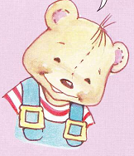  BENNY/ SUE | 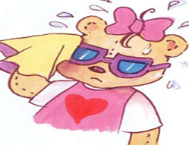  SUE/ BENNY
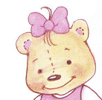  SUE/ BENNY | 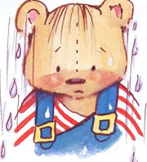  BENNY/ SUE
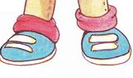  SUE/ BENNY | SUE/ BENNY
SUE/ BENNY | 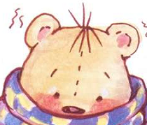  SUE/ BENNY
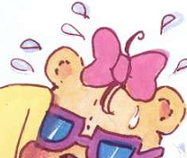  SUE/ BENNY | 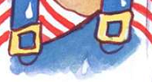  SUE/ BENNY
Exercise 2: or
BENNY | 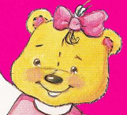 | 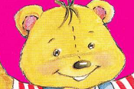
SUE | 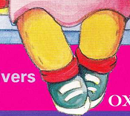
BENNY | 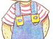 | 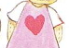
SUE |  | 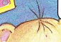
BENNY | 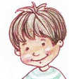

Exercise 3: Odd one out
1 | A. Benny | B. Sue | C. wet
2 | A. hello | B. cold | C. hi
3 | A. Benny | B. hi | C. hello
4 | A. hello | B. Benny | C. Sue
5 | A. Benny | B. hello | C. Sue

Exercise 4: Look and write u, e, a, o, i
B__nny | S__e | Su__ | Hell__
H__llo | H__ | S__ __ | H__ll__

Exercise 5: Look and write:
- y n n e B > ……… | - u e s > …………
- n n e y b > ………. | - S e u > ……………
- e u s > …………… | - y n e n b > …………..

Exercise 6: Write Benny, Sue or Hello
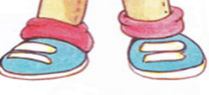  ……………. | …………….
………….. | 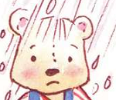  ……………….
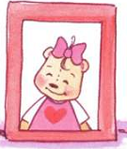  …………….. | 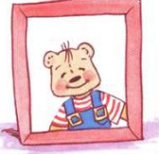 …………….
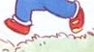  …………….. | 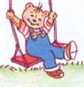  ………………….
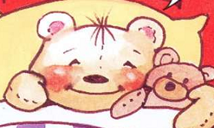  ……………… | 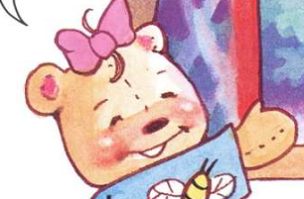  ……………

B. SENTENCES
Exercise 1: Look and circle
- I’m Benny.  - I’m Sue. | 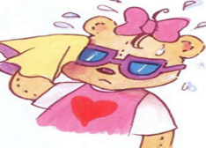  - I’m Benny.  - I’m Sue.
- Hello  - I’m Sue. | - Hi,  - I’m Benny.

Exercise 2: Fill in the blanks.
Hello, I’m……. | 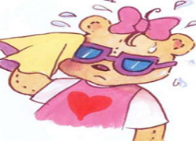  Hello, I’m ………..
Hi, I’m ……….. | Hi, I’m ……………….

THE END

