REVIEW CLASS 2
- Vocabulary
Exercise 1: Look and circle
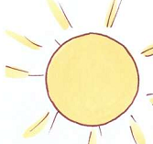  sunny/raining | 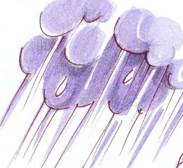  snowing/ raining
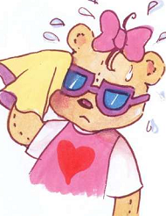  cold/ hot | 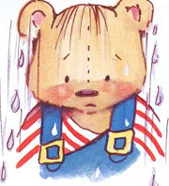  cold/ wet
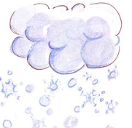  snowing/ raining | 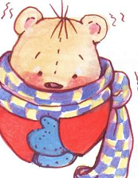  cold/ hot

Exercise 2: Look and write u, e, a, o, i.
s__nny | c__ld
h__t | r__inging
w__t | snow__ng
sn__w__ng | ra__ning
Exercise 3: Odd one out
1 | A. Benny | B. Sue | C. wet
2 | A. boy | B. cold | C. girl
3 | A. sunny | B. book | C. crayon
4 | A. snowing | B. up | C. down
5 | A. teacher | B. boy | C. raining
6 | A. hot | B. jump | C. cold
7 | A. four | B. wet | C. five
8 | A. clean up! | B. raining | C. snowing
9 | A. turn around | B. wet | C. cold
10 | A. cold | B. stand up | C. hot
11 | A. one | B. three | C. snowing
12 | A. one | B. blue | C. four
13 | A. sunny | B. jump | C. snowing
14 | A. cold | B. wet | C. sunny
15 | A. hot | B. snowing | D. raining

Exercise 4: Look and match
 | raining | 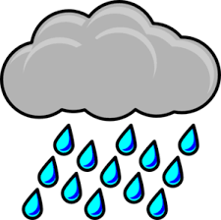
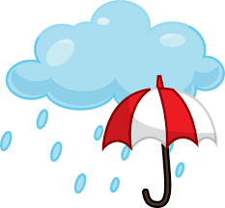 | sunny
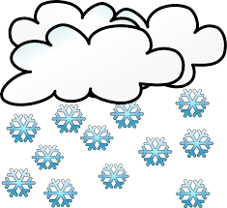 | snowing | 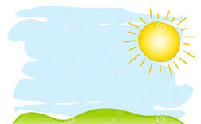

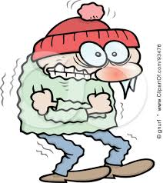 | cold | 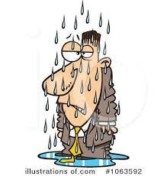
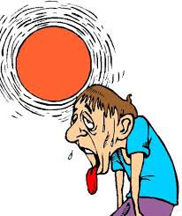 | wet | 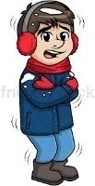
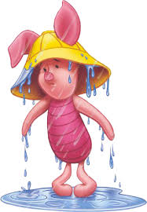 | hot | 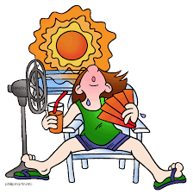

Exercise 5: Look and write:
- t e w > ……… | - y n n u s > …………
- t o h > ………. | - o t h > ……………
- g n i w o n s > …………… | - w t e > …………..
- g n i n i a r > ……………. | - r a n i i g n > …………..
- d l o c > ………….. | - g n s n o i w > ……………

Exercise 6: Look and write
1.………………………. | 2.………………………..
3.…………………… | 4.……………………….
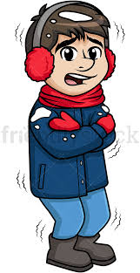  5.…………………….. | 6.…………………….
7.………………….. | 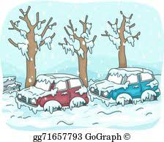  8.…………………..
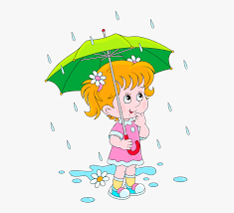  9.……………. | 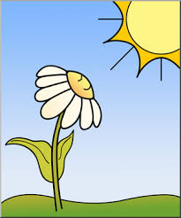  10……………………
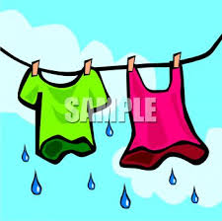  11……………………. | 12………………

