REVIEW CLASS 4
Exercise 1: Find, circle and write the words.
u g r | …………… | c b n e t a i | ……………
g u b | …………… | k e t b l n a | ……………
x f o | …………… | n n e t e n e i | ……………
s x t e e n i | …………… | p o l l w i | ……………
f l h s e | …………… | t w l v e e | ……………
n t y e w t | …………… | t e e f u o n r | ……………
t e e e g h n i | …………… | r t e e n t h i | ……………
e e l v n e | …………… | f f t e n e i | ……………

Exercise 2: Read and circle
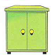  - There is a cabinet.  - There are two cabinets. | 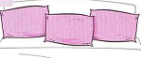  - There is a pillow.  - There are three pillows. | 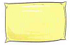  - There is a pillow.  - There are three pillows.
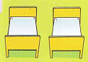  - There are two beds.  - There is a bed. | 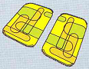  - There is a rug.  - There are two rugs. | 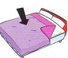  - There is a blanket.  - There is a blankets.
Exercise 3: Write the words in the correct box.
cabinet | chair | twenty | bag | thirteen | pencil
Sunday | eleven | shelf | Thursday | rug | Friday
Monday | eighteen | Wednesday | book | bed | table
pillow | Tuesday | blanket | lamp | nineteen | eraser

things of bedroom | ………………………………………………………………….  ………………………………………………………………….
numbers | ………………………………………………………………….  ………………………………………………………………….
days | ………………………………………………………………….  ………………………………………………………………….
school things | ………………………………………………………………….  ………………………………………………………………….

Exercise 4: Look and write: There is or There are
- ..................four balls.  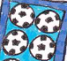 | - ……………..a cabinet.  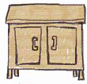
- ………….a shelf. | - ………………two rugs.  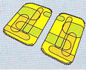

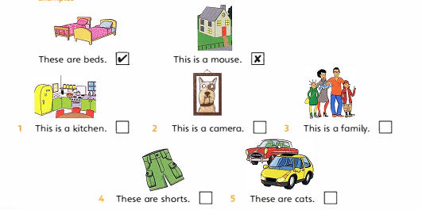
Exercise 7: Look and write
……………... | ……………... | …………….. | ……………...
  

