REVIEW CLASS 5 ( SO 1)

- READING:
I. Choose the answer. Write the letter (2 points).

a. I’m from Vietnam. |  | b. No, I don’t. |  | c. | My name’s Tim.
d. Yes, they are. |  | e. He likes reading. |  | f. | I’m taking photos.
0. | What’s your name? | c | 1. | Where are you from?
2. | What does he like? |  | 3. | Do you wear a hat?
4. | What are you doing? |  | 5. | Are they eating?

II. Look and write A or B (1 point).
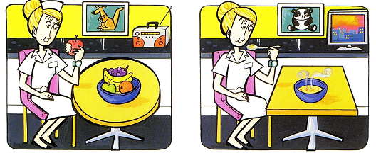
B
A

1 | The woman is eating some soup. | ……B…..
2 | There is a photo of a kangaroo. | ………..
3 | The woman is watching TV. | ………..
4 | The woman is listening to the radio. | ………..
5 | There is a picture of a panda. | ………..
- WRITING:
- Reorder the words to make the sentences ( 2 points).
- like / I / fishing /./ I like fishing.
- They / shopping / at/ like /weekends /. / _____________________
- season/ My/ is/ winter/ favorite/./ _______________________
- don’t/ I / like / comics/ reading/./ ________________________
- is/ giraffe/The/ than/ taller/ zebra/ the/./_____________________
- Write the questions (2points).
- What time do you go to school?
I go to school at seven o’clock.
- _________________________________?
Yes, she does. She likes doing gymnastics.
- _________________________________?
I like swimming at the beach.
- _________________________________?
He has one hundred shells.
- _________________________________?
They are from Korea.

REVIEW ( SO 2 )

Exercise 1: Look and circle.
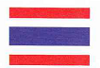  I’m from Thailand/ Japan. | He’s from Australia/Vietnam.
They’re from Mexico/the U.S.A | She’s from Brazil/ Vietnam.
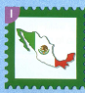  We’re from Korea/ Mexico. | I’m from Vietnam/ the U.S.A.
He’s from Korea / Mexico. | They’re from Thailand/ Mexico.

Exercise 2: Rewrite the sentences
No | sentences | sentences
1 | What/ your/ name/’s /? | ……………………………………
2 | goodbye/ you/ to | ……………………………………
3 | old/ are/ you/?/how | ……………………………………
4 | today/are/ how/?/ you/ | ……………………………………
5 | I/’m/ Vietnam./ from | ……………………………………
6 | They/ from/’re/ Brzail. | ……………………………………
7 | to/ Nice/ you./ meet | ……………………………………
8 | drink/ from/ We/ cup./ a | ……………………………………
9 | He/ from/ Australia./’s | ……………………………………
10 | all/ play/ afternoon./ We | ……………………………………
11 | with/ crayon./ We/ draw/ a | ……………………………………
12 | from/’re/ We/ Thailand. | ……………………………………
13 | are/ Wher/ from/ you/ ? | ……………………………………
14 | I/ Lucy/ friends/ are | ……………………………………
15 | Danny/ brothers./ Kenny/ are | ……………………………………
16 | The/ is/ than/ elephant/ bigger/ the / tiger. | ……………………………………
17 | taller/ The/ is/ giraffe/ than/ zebra./ the | ……………………………………
18 | sunny./ was/ It | ……………………………………
19 | have/ two/ cousins./ We | ……………………………………
20 | have/ months/ We/ twelve/ a/ in/ year. | ……………………………………

Exercise 3: Look and write: How old are you?
I’m from Mexico. | He……………. | They……………. | We……………

She…………….. | I………………. | You………………. | We……………….

Exercise 4: Write an answer
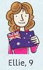  Where is she from?  …………………… | Where is he from?  …………………….. | 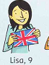  Where is she from?  ….............
Is it a boy?  ………………….. | 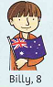  How old is he?  ……………………. | 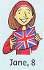  Is it a girl?  ……………………

