GRADE 1
TINY TALK 1A
(Exercises)
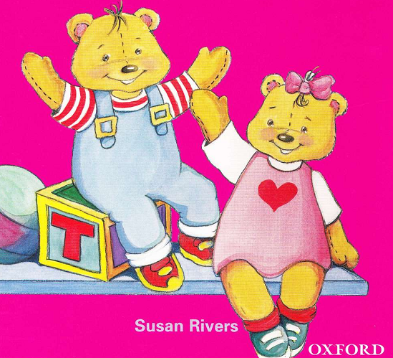

Name: ………………………………………………………….
Class: ………………………………………………………….
UNIT 1: HELLO!
- VOCABULARY
Exercise 1: Look and circle.
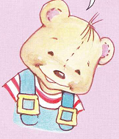  BENNY/ SUE | 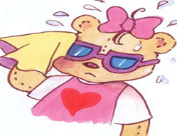  SUE/ BENNY
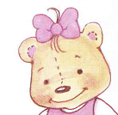  SUE/ BENNY | 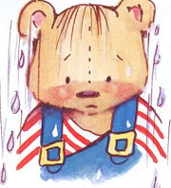  BENNY/ SUE
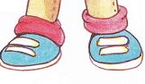  SUE/ BENNY | SUE/ BENNY
SUE/ BENNY | 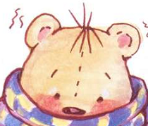  SUE/ BENNY
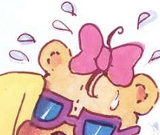  SUE/ BENNY | 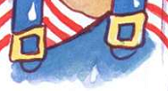  SUE/ BENNY
Exercise 2: or
BENNY | 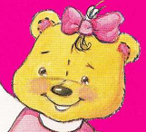 | 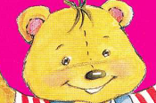
SUE | 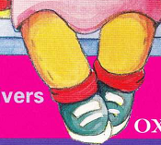
BENNY | 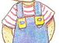 | 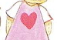
SUE |  | 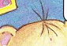
BENNY | 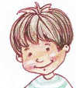 | 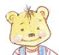

Exercise 3: Odd one out
1 | A. Benny | B. Sue | C. wet
2 | A. hello | B. cold | C. hi
3 | A. Benny | B. hi | C. hello
4 | A. hello | B. Benny | C. Sue
5 | A. Benny | B. hello | C. Sue

Exercise 4: Find out “SUE, BENNY, and HELLO”
B | E | N | N | Y | H | S
E | U | S | U | E | E | U
N | S | U | E | Y | L | E
N | U | E | U | N | L | H
Y | E | U | S | N | O | E
Y | U | S | U | E | E | L
H | S | U | E | B | U | L
H | E | L | L | O | S | O
Exercise 5: Look and match
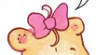 | BENNY
 | HELLO | 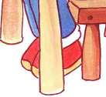
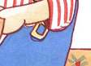 | SUE

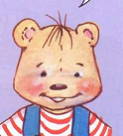 | SUE | 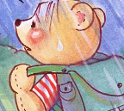
 | BENNY | 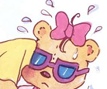
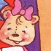 | HELLO | 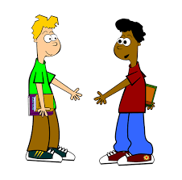
Exercise 6: Look and write u, e, a, o, i
B__nny | S__e | Su__ | Hell__
H__llo | H__ | S__ __ | H__ll__

Exercise 7: Look and write:
- y n n e B > ……… | - u e s > …………
- n n e y b > ………. | - S e u > ……………
- e u s > …………… | - y n e n b > …………..

Exercise 8: Write Benny, Sue or Hello
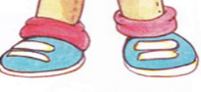  ……………. | …………….
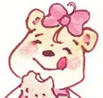  ………….. | 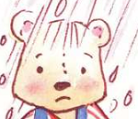  ……………….
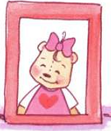  …………….. | 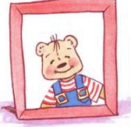 …………….
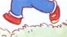  …………….. | 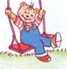  ………………….
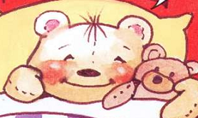  ……………… | 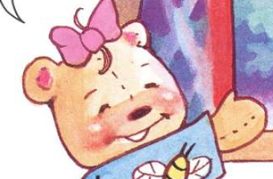  ……………
Exercise 9: Listen and write
Hi, (1)…………, hello.
Hi, (2)…………, hello.
(3) …………, hello, (4)…………….., hello.
Hi, (5)………………., hi, (6)………………..
(7)………….., hello, (8)………………., hello.
Hi, (9)……………….., hi, (10)………………

B. SENTENCES
Exercise 1: Look and circle
- I’m Benny.  - I’m Sue. | 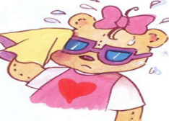  - I’m Benny.  - I’m Sue.
- Hello  - I’m Sue. | - Hi,  - I’m Benny.

Exercise 2: Fill in the blanks.
Hello, I’m……. | 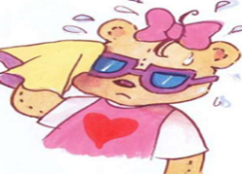  Hello, I’m ………..
Hi, I’m ……….. | Hi, I’m ……………….

THE END

